Architecture and design document

Collaborative work

Index
Document History 3
Version History 4
Introduction 5
Technical constraints 5
Control Mode 5
Control an UML model 5
Control a notation model 5
Control a DI model 6
DI resource management 6
Resources content 8
EMF resources 9
Notation resource 9
DI resource 10
Proposals 11
Solution 1 11
Solution 2 11
Solution 3 11
Other solution ? 12
Uncontrol action 12
Export Mode 12
Architecture 13

Document History

Date | Comments
2009-08-24 | Describe technical solution for control mode
2009-11-16 | Refine specification for control mode and a proposals to fix known issues

Version History

Version | Date | Author | Company | Comments
1.0r1 | 2009-08-24 | Emilien PERICO | Atos Origin | Initial content
1.0r2 | 2009-11-16 | Emilien PERICO | Atos Origin | Add content for control mode

Introduction
This document aims to describe the architecture of components and plugins used to implement the collaborative work.
Technical solution for each mode is described to ensure feasibility. A prototype could be made to check the proposed solution.

Requirements
The functional requirements are listed in another document.

What can be controlled ?
The unit of control is the package.
It should be possible to add the diagram as unit of control.
In fact a diagram is similar to a package, in the sense it is a container containing elements that can be edited (i.e. written) by the user.

Technical constraints

Control Mode
Control action comes from EMF component (org.eclipse.emf.edit). This action enables to split a part of a resource to export it in a single one.

To set up the control mode on MDT Papyrus models and diagrams, we need to allow this mechanism on uml, notation and di model.

Control an UML model
Since EMF 2.2, support was added so that if a containment reference is proxy resolving (EReference.isResolveProxies() is true), an object can be added to the contents of a resource without removing it from its container's proxy resolving reference.
Control is already available on UML model. We will be able to use it on UML Papyrus model.

Control a notation model
Notation meta model is part of GMF, use to represent graphical part of models based on GMF editors. Unfortunately the control action is not available on elements of this meta model.

An object is only controllable if it is fulfil these conditions:
(part of the sources of org.eclipse.emf.edit.domain.AdapterFactoryEditingDomain)

public boolean isControllable(Object object)
{
if (!(object instanceof EObject)) return false;
EObject eObject = (EObject)object;
EObject container = eObject.eContainer();
return container != null
&& eObject.eContainmentFeature().isResolveProxies()
&& !isReadOnly(eObject.eResource())
&& !isReadOnly(container.eResource());
}

Additional informations here:
http://dev.eclipse.org/newslists/news.eclipse.modeling.gmf/msg19364.html

Actually, control action on notation meta model is need-not to perform the split of the graphical resource. We can create a new resource into the existing resource set. This new resource contains the diagrams node of the controlled UML element. We have made a prototype to ensure the feasibility. Change the diagram reference of a notation model enables to split the notation in a controlled resource.

Control a Sash DI model
Sash Di meta model comes from org.eclipse.papyrus.sasheditor.di.

The sash Di model contains two things:
- A list of available diagrams.
- A representation of the opened diagrams and their relative positions in windows.

While it is possible to Control the sash di model, it is also possible, and maybe simplest, to recreate it after a control or an uncontrol.

Recreate di After control
The di model can be shared or copied among the user without spliting it. It is also possible to reduce the set of available diagram in one of the copy.

Recreate di After Uncontrol
In case there is several di models to merged, this can be done manually:
- Lists of diagram are merged (simple union)
- Structure of opened diagram can be:
- resetted: all diagrams are closed
- or merged: both set of opened diagrams are shown side by side
- A mix of both ...

Doing control on DI resource
Following is an example of using control on the Di.
This solution is not recommended.

When you control a model, controlled model elements and diagrams are moved to the controlled resource. In the example below, Package0 is controlled in Model2

You can open model2.di or Package0.di as a single resource. Model2.di always contains the references to the controlled diagram. These ones are resolved once the control action is done

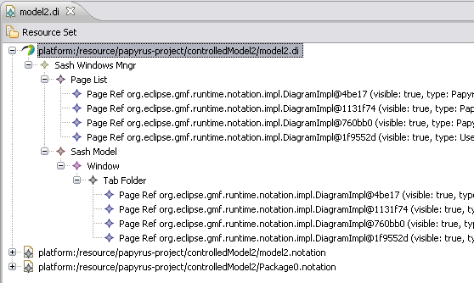
Now if you try to control Package0, which is already controlled and managed as a single resource, you loose references to the new controlled resource in model2.di. See example below:

Package100 is controlled:
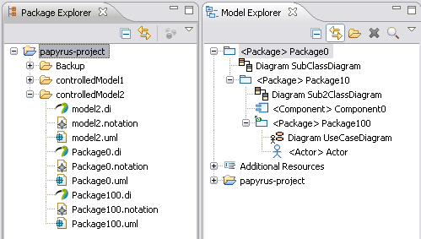

In model2.di, UseCaseDiagram from Package100 can not be resolved. Model2.di can not be opened.

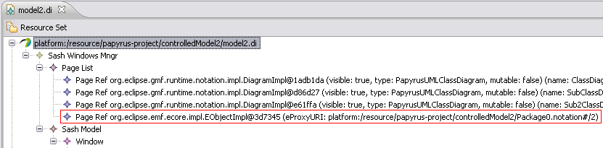
To fix this problem, the proxy object must be resolved. But when you control Package0, you don't have reference to model2 to resolve it.

When we will want to manage profiles and stereotypes in controlled models, we will need this reference to reach the model with the applied profile.

Resources content
Here is an example to understand each resource content when control action is done. In Model1, Package0 is controlled to be stored in a single resource:

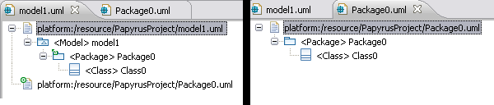

EMF resources
Model1.uml
<uml:Model xmi:version="2.1"
xmlns:xmi="http://schema.omg.org/spec/XMI/2.1" xmlns:uml="http://www.eclipse.org/uml2/3.0.0/UML"
xmi:id="_iYgO4NKcEd6nUdI_nGUQtw"
name="model1">
<packagedElement xmi:type="uml:Package" href="Package0.uml#_jW7mANKcEd6nUdI_nGUQtw"/>
</uml:Model>

Package0.uml
<uml:Package xmi:version="2.1"
xmlns:xmi="http://schema.omg.org/spec/XMI/2.1" xmlns:uml="http://www.eclipse.org/uml2/3.0.0/UML" xmi:id="_jW7mANKcEd6nUdI_nGUQtw"
name="Package0">
<packagedElement xmi:type="uml:Class"
xmi:id="_tbaisNKcEd6nUdI_nGUQtw"
name="Class0"/>
</uml:Package>

Package0 is added to the contents of Package0.uml resource without removing it from its container's proxy resolving reference (Model1.uml). This one keeps the reference to the controlled object.

Notation resource
Model1.notation
<notation:Diagram ...
type="PapyrusUMLClassDiagram"
name="ClassDiagram" >
<children xsi:type="notation:Shape" ...>
...
</children>
<element href="model1.uml#_iYgO4NKcEd6nUdI_nGUQtw"/>
</notation:Diagram>

Package0.notation
<notation:Diagram ...
type="PapyrusUMLClassDiagram"
name="SubClassDiagram" >
<children ...>
...
</children>
<element href="Package0.uml#_jW7mANKcEd6nUdI_nGUQtw"/>
</notation:Diagram>

In notation model, there is only a reference to the model object. Control action is not available on Diagram. So you loose the reference to a Diagram object when you add it to a new resource content.
We previously saw that when you try to perform control with several levels, you can't resolve container's proxies.

DI resource
The sash Di contains two things:
- A list of available diagrams.
- A representation of the opened diagrams and their relative positions in windows.

Model1.di
<di:SashWindowsMngr>
<pageList>
<availablePage>
<emfPageIdentifier href="model1.notation#/"/>
</availablePage>
<availablePage>
<emfPageIdentifier href="Package0.notation#/"/>
</availablePage>
</pageList>
<sashModel>
<windows>
<children xsi:type="di:TabFolder">
<children>
<emfPageIdentifier href="model1.notation#/"/>
</children>
<children>
<emfPageIdentifier href="Package0.notation#/"/>
</children>
</children>
</windows>
</sashModel>
</di:SashWindowsMngr>

Package0.di
<di:SashWindowsMngr>
<pageList>
<availablePage>
<emfPageIdentifier href="Package0.notation#/"/>
</availablePage>
</pageList>
<sashModel>
<windows>
<children xsi:type="di:TabFolder">
<children>
<emfPageIdentifier href="Package0.notation#/"/>
</children>
</children>
</windows>
</sashModel>
</di:SashWindowsMngr>

A DI model just keeps a reference to the notation models. For the same reasons as notation models, you can't resolve container's proxies because you don't have a reference between a container and its controlled object.

Proposals
Notation and DI meta model does not provide control action natively. We saw that we loose informations when control is performed at several levels. We must find a way to keep reference between controlled Resources model and its container. We also should think about a flexible solution that will be usable with export mode.

Following are several proposals.
- The 3 first ones implies controling the DI
- The 4th is a solution with no modification of the di

Solution 1
A first solution is the modify the DI meta model to be able to control pages. For this setting of the Ecore model to be respected by the generator, we must set the GenModel's "Containment Proxies" property to true. Meta model architecture must be refined to have a better management of page references. This solution implies refinement but will be the most flexible.
We must add some restrictions on conditions that enables control action.

Solution 2
Another way is to add a reference to the parent DI resource like this:
<parent href="Container.di#_id1"/>
This reference will enable us to reach the container. The main drawback of this solution is that you see all the content of the parent model in you controlled resource. Let see the example below:
On the left part, you've got the full model and Package1 is controlled.
On the right, this is the resource Package1.uml. You can see that you get the content of the parent model. It is loaded as additional resource.
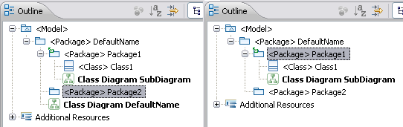
Besides, this behaviour will be a problem for export mode because we don't want to see the container of an exported model.

Solution 3
When the control is active on EMF model, we can see that a container references an object from its controlled resource:
<packagedElement xmi:type="uml:Package" href="Package0.uml#_jW7mANKcEd6nUdI_nGUQtw"/>

We could think about the same mechanism between DI models, setting up a PageList Ref contained in a Page List or a Sash Window Manager that references a page list in a controlled resource. Page references are not duplicated anymore in all the resources but a reference is used.
It will be the same mechanism as EMF without native proxy resolving. With this solution, we must manage the control and uncontrol action manually but we keep a top-down reference.
It would be something like that
Model1.di
<di:SashWindowsMngr>
<pageList xmi:id="id1" >
<availablePage>
<emfPageIdentifier href="model1.notation#/"/>
</availablePage>
</pageList>
<pageList Ref href="Package0.notation#/id2"/>
<sashModel>
...
</sashModel>
</di:SashWindowsMngr>

Package0.di
<di:SashWindowsMngr>
<pageList xmi:id="id2" >
<availablePage>
<emfPageIdentifier href="Package0.notation#/"/>
</availablePage>
</pageList>
<sashModel>
...
</sashModel>
</di:SashWindowsMngr>

Solution 4
The sash di model is not controlled. It is merged or splitted when the resources are controlled (see Control a Sash DI model).
An additional model is added : controlmode model. It contains data required to maintain the references between controlled resources. This model is present only if some resources are controlled. This model can be stored in the same resource as the di model (but it is not part of the di model). This will reduce the number of resources (Is it really nbecessary, because as soon as we split some resources, the number increase :-) ).
The exact content of the controlmode model is to be defined.

Other solution ?

Uncontrol action
The uncontrol action is the reflective behavior of control action. From a model having controlled resources, you can uncontrol it. This one is merged to the parent model and the resources are deleted.

Export Mode
TODO

Architecture

For now, control action from EMF is overridden in a PapyrusControlAction to manage control for notation resource and di resource.
This class was created in org.eclipse.papyrus.navigator plugin in order to access EditingDomainActionProvider and NavigatorUtils.

It's not possible to export this action in a single plugin because of cycling dependencies. Extension points must be used to avoid dependencies problems. Refactoring is needed on DiResourseSet and BackboneContext before.

Here is a components model we plan to set up:

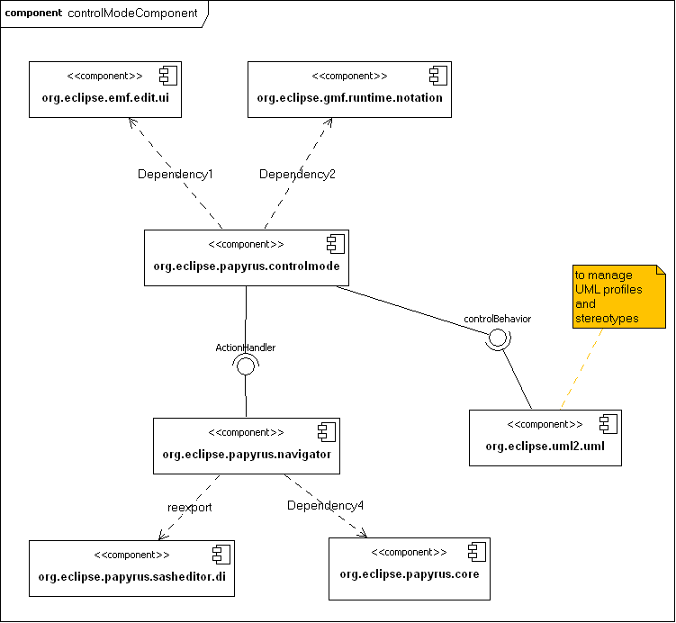

A single plugin (org.eclipse.papyrus.controlmode) will be in charge of split the specified model to have a controlled resource.
This one depends on sasheditor.di, gmf.runtime.notation and emf.edit.ui for di, notation and emf (such as uml) resources management.

An extension point (actionHandler) will allow adding additional actions on navigator menu.
Another extension point will allow managing UML profiles in the control mode plugin. This one need to be define precisely.

